User Management
User Management screen allows to create user profiles in the system.
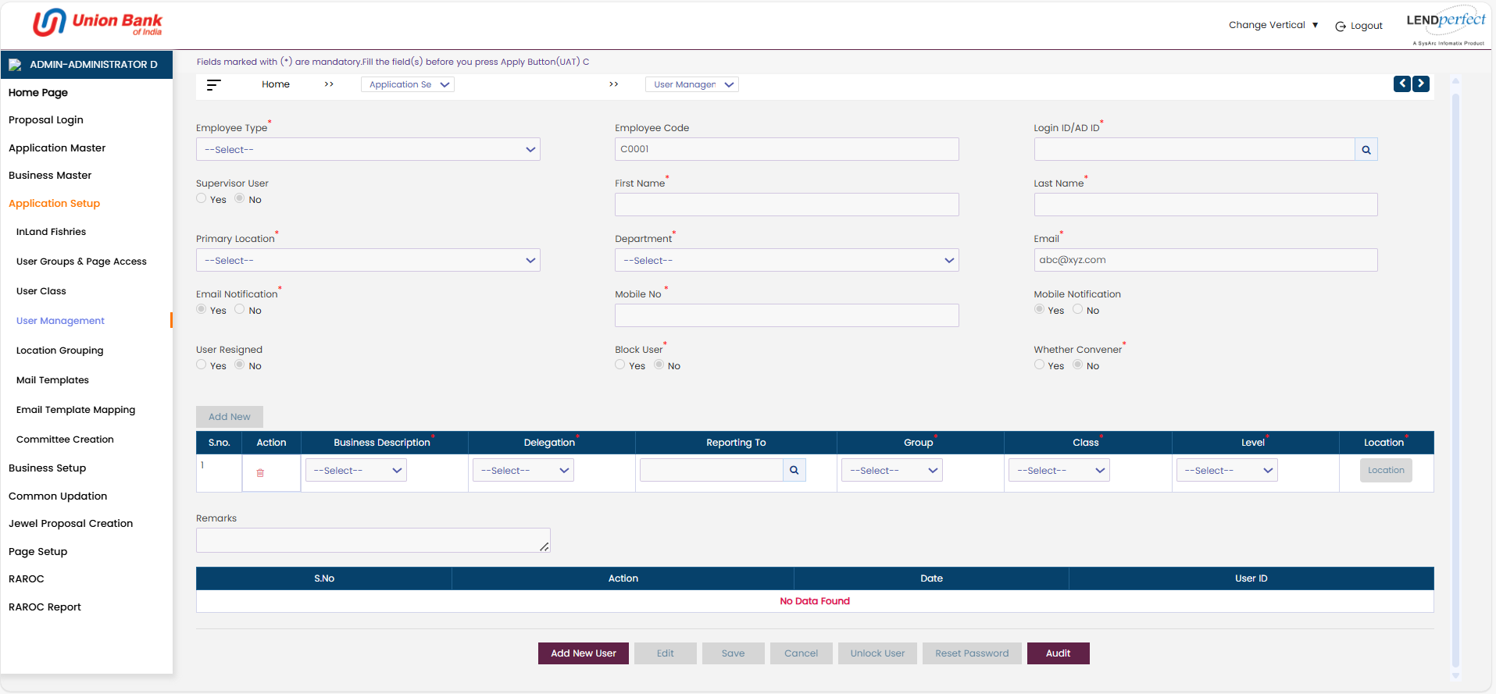
Creating a new user profile
On the User Management screen, click Add New User button. The User Management screen displays blank. Enter the user details. The fields with * are mandatory. Enter inputs in all the mandatory fields to save the document. Assign the user to business descriptions. Associate the user to a reporting head, user group, and class, assign a designation to the user, location, and level. The access rights to the user are determined by the class to which the user is assigned to. Provide login credentials to the users. Enter any comments about the user for future references.
Super Admin
A Super Admin can view and modify proposals across all locations without restriction (for example, Chennai, Bangalore, or Mumbai), while an Admin can view and modify only the proposals that belong to their assigned location (for example, a Chennai Admin can update only Chennai and their hierarchy proposals and cannot access Bangalore or Mumbai proposals).

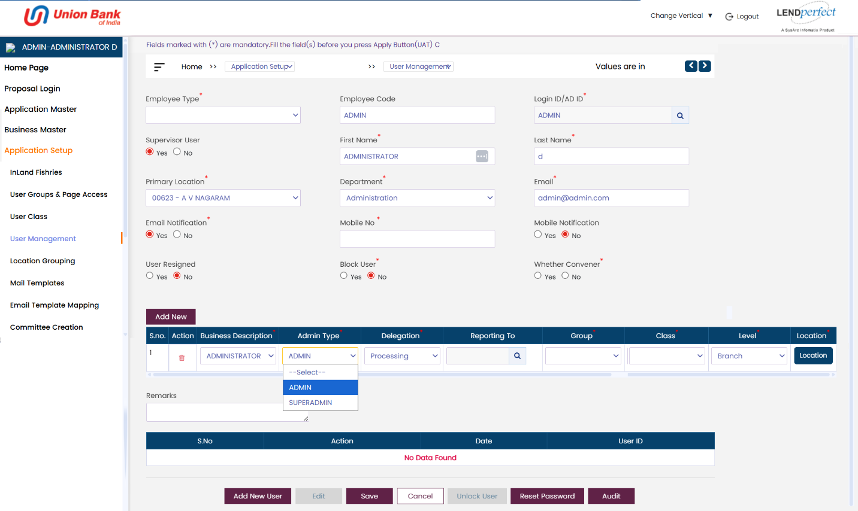
Click Edit and select SUPERADMIN from Admin Type dropdown then enter all the remaining details.
Assigning a user to a location
Click corresponding to the user designation created. The following pop-up displays.
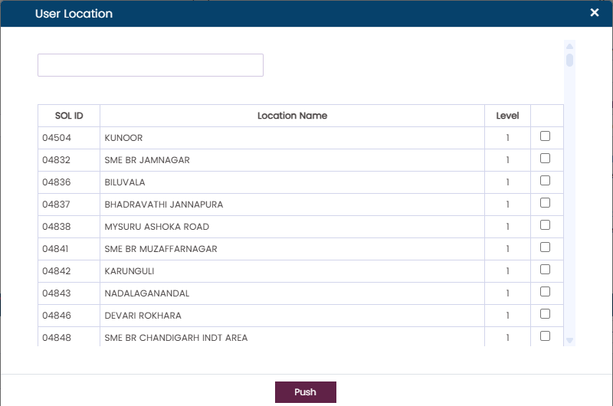
On the pop-up screen, select a single or multiple location name(s). Click Push. The selected locations will be assigned to the users of the selected designation to process the loan applications. Click Save to confirm. Upon confirmation, the loan applications from the selected locations will be pushed to the selected users' inbox for processing.
Editing used data
On the User Management screen, click  select the user profile from the database. Click the Edit button. The User Management screen displays in edit mode. Edit the details. Click Save to confirm.
Blocking user access
On the User Management screen, click  select the user profile from the database. Click the Edit button. Select Yes radio button corresponding to Block User. Select the reason for blocking the user from the Blocker type drop-down. The user will not be able to log in to the SysArc System.
Unblocking User
 | The button will be enabled only if the selected user was previously blocked.
On the User Management screen, click  select the user profile from the database. Click the Edit button. Select No radio button corresponding to Block User. The user will be able to log in to the Sysarc System.
Reset password
 | The button will be enabled only if the user failed to login to the system.  i.e.: upon expiry of the maximum trials to login with an incorrect password.
On the User Management screen, click  select the user profile from the database. Click the Reset Password button to change the password for the user.

User additional Access
The Additional User Access feature allows you to assign one or more additional roles to an existing user along with a defined validity period.
The user’s existing role is displayed as the Primary Role. Additional roles can be assigned temporarily using a timeline (From Date and To Date). Once assigned, the additional role appears in the Additional User Access grid.

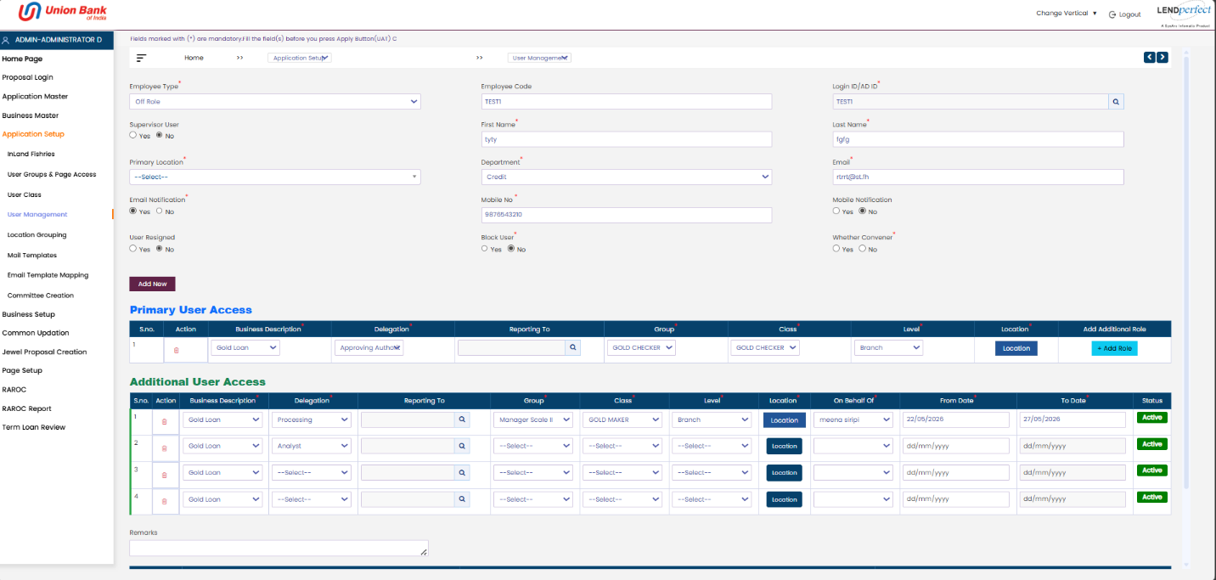
In the Primary User Access section, click Add Row. A new row will be added to the Additional user Access grid.
In the newly added row, provide the following details:
- Business Description – Select the applicable business function.
- Designation – Select the additional role to assign.
- Reporting To – Choose the reporting manager (if applicable).
- Group – Select the group.
- Class – Select the class.
- Level – Select the level.
- Location – Choose the location.
- On Behalf Of – Select the user for whom the role is assigned.
The additional role is active only between the From Date and To Date.
Once the defined timeline expires:
- The row is automatically disabled.
- The Status changes to "Inactive"
The system sends a reminder notification to the assigned user before the role expires. Multiple additional roles can be added using Add Row. Each row displays a Status indicator.
The grid supports managing multiple role assignments simultaneously. Remarks can be entered in the Remarks section at the bottom.

Location Deputation
The Location Deputation feature allows assigning an additional role across one or more locations for a specific time period.
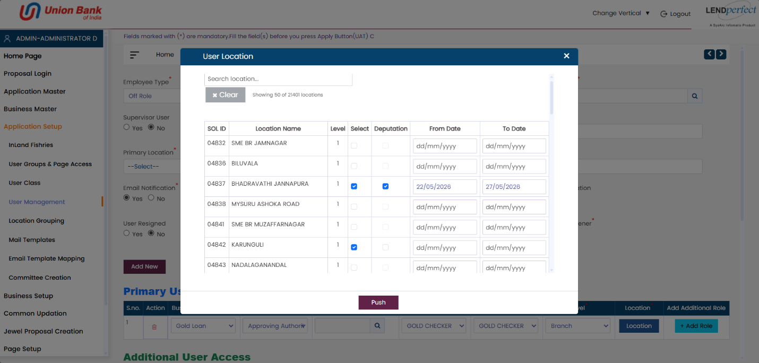
Navigate to the Additional User Access section. Add a new row or select an existing row where the role needs location-based assignment. In the selected row, click the Location button. Use the Search Location field to find a specific location. Select the required location’s by clicking the Select checkbox. For the selected location’s, check the Deputation checkbox.
This enables role assignment for the selected locations.
Enter:
- From Date – Start date for deputation.
- To Date – End date for deputation.
Click Push to apply the selected locations and deputation details. The selected location(s) and timeline are updated in the Additional User Access grid.
The deputed role is:
- Active only during the defined date range.
- Automatically follows the timeline configured.
After the additional role is assigned, the user can switch and access it by selecting the required role from the Your Working Role dropdown, where only active roles are displayed.
